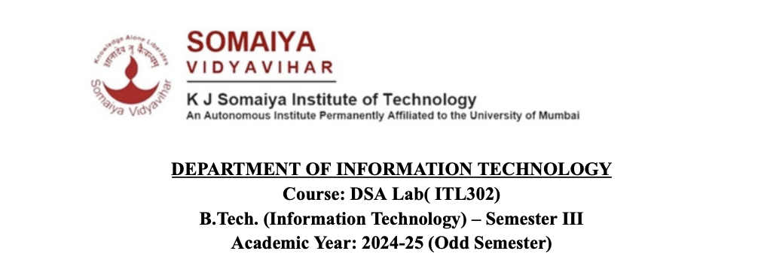

**Experiment no.2**

**Aim:** Implementation of Queue using Array for real-world application.

**Code:**

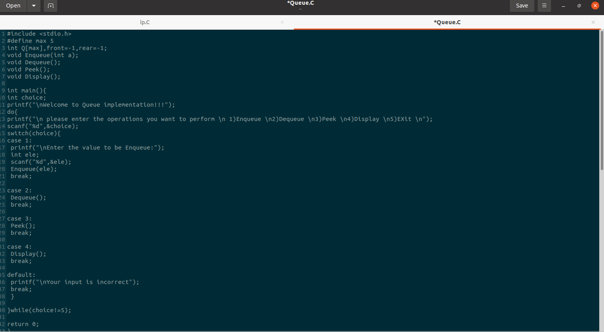

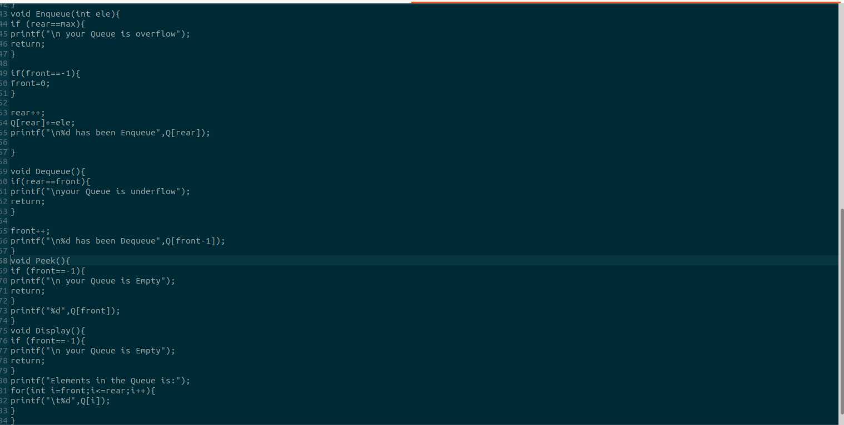

**Output:**

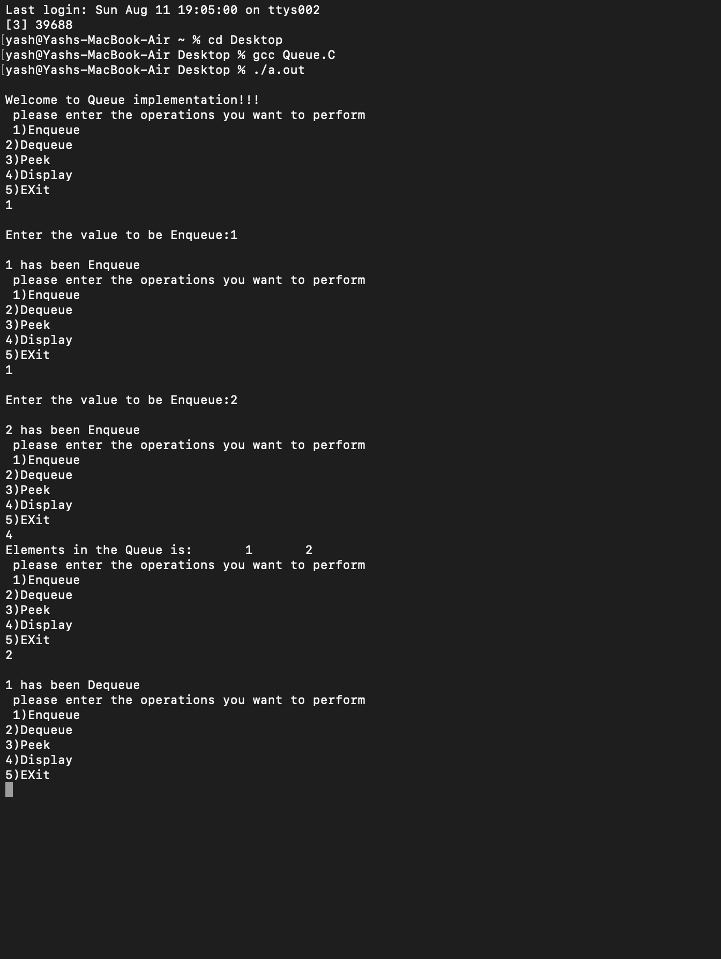

**Submitter Details -  
Name of Student:** Yash.M.Dharamshi

**Roll No.:** 22 **Date of Performance:** 09/08/2024

**Date of Submission:**11/08/2024